

Nursery SEND and Inclusion Policy

Signed by:
 | Nursery Manager | Date:
 | Chair of governors | Date:

At Maidenbower Infant School Nursery we have a child-centred and inclusive ethos. We aim to teach each pupil at an appropriate level, ensuring that our curriculum meets the needs of all our pupils. We believe that all children have individual educational needs. We aim to help all children achieve success and feel positive about themselves and their learning.

This policy has been written with regard to the:
DfE SEND code of practice 2015
Children and Families Act 2014
Statutory framework EYFS 2025
Equality Act 2010

At Maidenbower Infant School Nursery we use the definitions for Special Educational Needs and Disability (SEND) as stated in the SEND Code of Practice (2015):

SEN: A child or young person has special educational needs if he or she has a learning difficulty or disability which calls for special educational provision to be made for him or her. A learning difficulty or disability is a significantly greater difficulty in learning than the majority of others of the same age. Special educational provision means educational or training provision that is additional to, or different from, that made generally for others of the same age in a mainstream setting in England.
Disability: Many children and young people who have SEN may have a disability under the Equality Act 2010 – that is ‘…a physical or mental impairment which has a long-term and substantial adverse effect on their ability to carry out normal day-to-day activities’. This definition includes sensory impairments such as those affecting sight or hearing, and long-term health conditions such as asthma, diabetes, epilepsy, and cancer.

Our commitment

* All children, whether they have additional support needs or are vulnerable are welcomed in the nursery. The admissions policy for all children is the same.

* In accordance with the Equality Act 2010, reasonable adjustments are made to ensure that no-one is disadvantaged. All routines and activities in the nursery are designed to encourage the development of every child’s self-esteem and confidence.

* The individual needs and progress of each child are monitored through our system of observation, assessment and record keeping and through our partnership with parents.

* The nursery follows a child led approach to teaching. Children are born with a natural desire to explore and learn and our staff members support them in this. We have created an inclusive, enabling and stimulating environment to enable us to do this. We do not plan ahead, rather we remain ‘in the moment’ with the children as they explore and learn. We observe the children carefully and enhance their learning by teaching them in their chosen activity.

* Our staff regularly attend training run by various professional bodies to promote inclusion.

* We acknowledge the importance of the role of the parent / carer. We are committed to working in partnership with parents to ensure that every child’s needs are met, enabling them to reach their full potential. Regular parent/carer and key person discussions provide an understanding of each child’s needs.

Identification and support of Special Educational Needs

* Concerns regarding a child’s development or rate of progress can be raised by parents/carers, external agencies and/or nursery staff.

- The nursery has a rigorous system of observation, assessment and ongoing monitoring. Where any child is not making the expected progress in line with ‘Development Matters’, the key person will share this with the parents/carers. If parents are concerned about their child’s development, they should share them with the child’s key person as early as possible.

* Provision for SEND is a matter for all staff. All staff are familiar with and use the West Sussex Ordinarily Inclusive Practice (OAIP) to inform provision. Every teacher is a teacher of SEND. The Code of Practice 2015 outlines a graduated response to children’s needs, recognising that there is a continuum of need matched by a continuum of support. This process is led by the SENCO and follows a cycle of Assess, Plan, Do, Review.

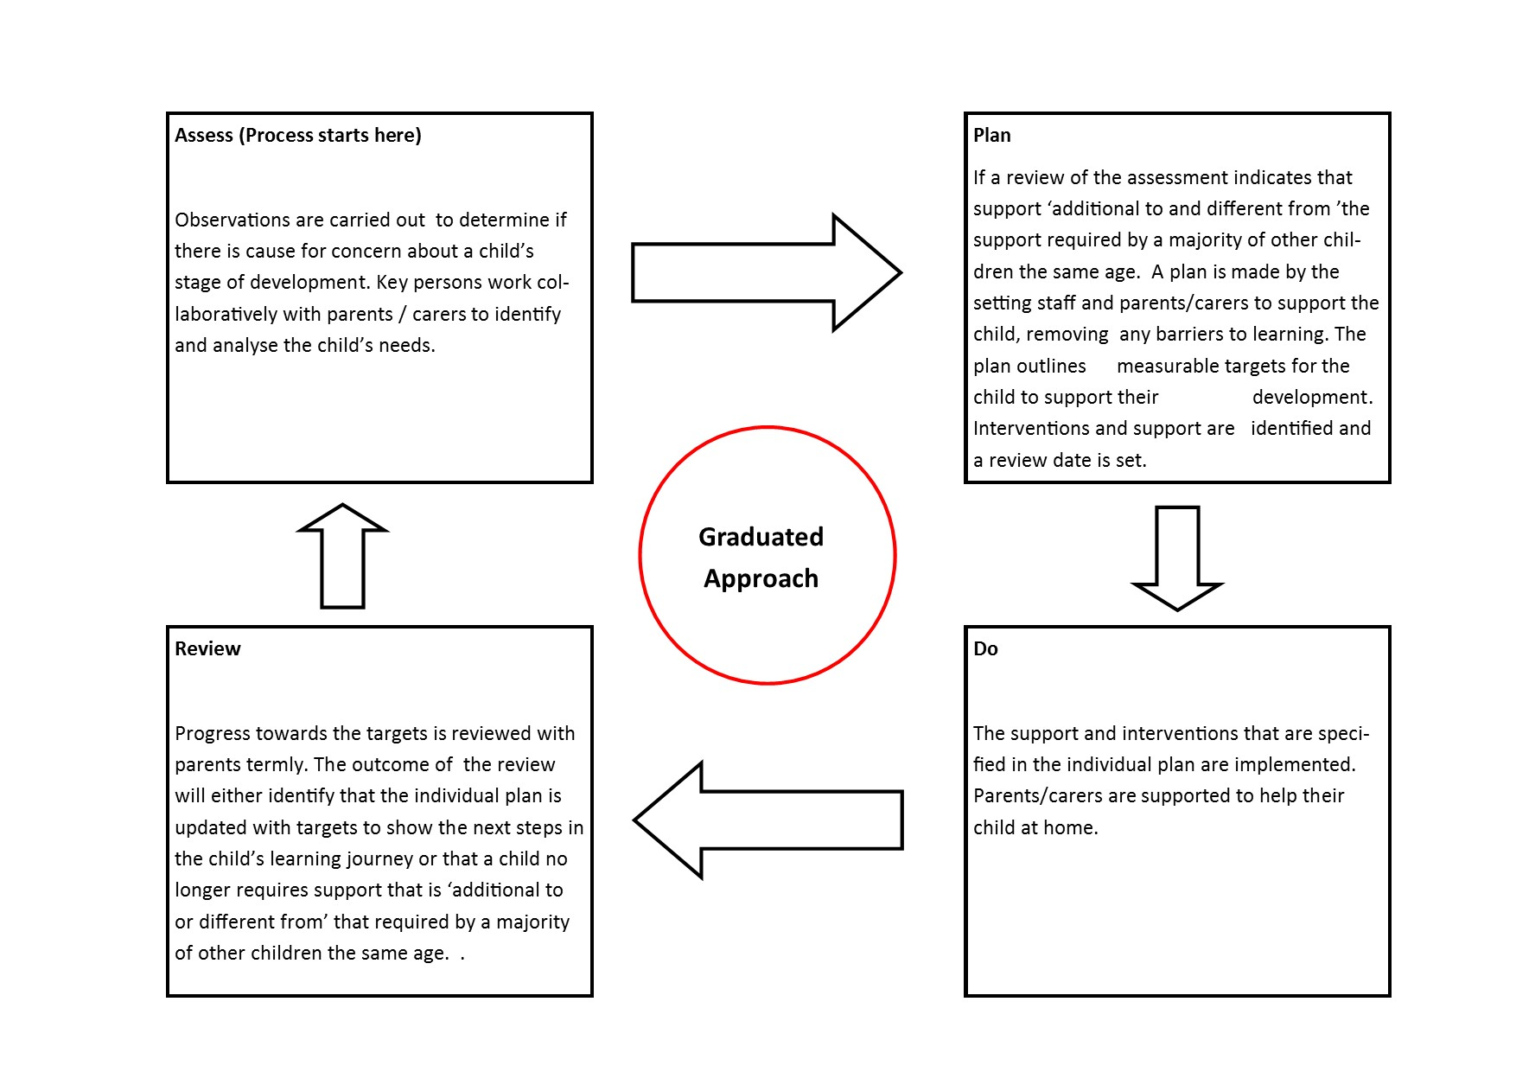

* Where progress is still judged to be insufficient despite the delivery of high quality interventions, in accordance with the SEND Code of Practice, advice will always be sought from other professionals for strategies to best support the specific needs of the child. Any referrals to another service or discussions with them will only take place after permission has been given by parents / carers. These professionals include health visitors, ethnic minority achievement service staff, portage workers, social workers and the Early Years Advisory team, Speech and Language Therapists and the Child Development Centre.

- The Nursery Inclusion Co-ordinators, Yvonne Bryant and Fiona Bumstead Grubb are responsible for implementing the Inclusion policy and liaising with parents and other professionals.

- Where required to support the child, the Nursery Inclusion Co-ordinators will make an application to access additional sources of funding e.g. DAF, Inclusion Funding. Applications will always be made in partnership with the parents / carers.

- Liaison with the previous settings and future settings of children with SEND will be comprehensive to enable the children to transition with as much support in place as needed. The SENCO will be responsible for arranging a transition meeting with both
settings and the family.
- Our Local Offer details the arrangements that the nursery offer to support children and young people with SEND. https://www.maidenbowerinfantschool.org.uk/local-offer/

Information and Support Services for parents of children with SEND include:

- SEND IAS offer independent and impartial information, advice and support to children and young people who have special educational needs and/or disabilities and to their parent / carers. https://westsussexsendias.org/

- Reaching Families was first established in 2008 by parent-carers to “empower, inform and support parents and families of children and young people with special educational needs and disabilities in West Sussex”. They offer training and support for parents and a benefits advice service. https://www.reachingfamilies.org.uk/

- Information about local services, support and events for children and young people aged 0-25 years who have special and educational needs and disabilities (SEND) https://westsussex.local-offer.org/

THIS POLICY WAS REVIEWED BY THE NURSERY MANAGER/GOVERNORS OF MAIDENBOWER INFANT SCHOOL AND NURSERY.

Next Review date: Autumn 2026

